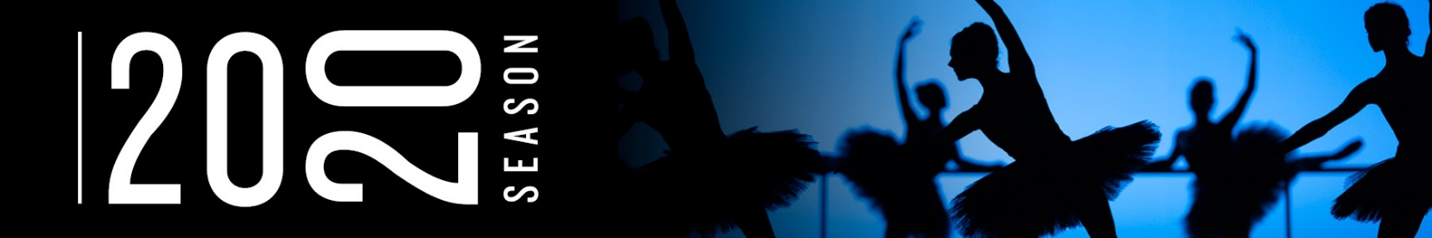San Francisco Ballet in Harald Lander’s *Etudes* // © Erik Tomasson

**SAN FRANCISCO BALLET ANNOUNCES**

**2020 REPERTORY SEASON**

***Highlights of Artistic Director and Principal Choreographer Helgi Tomasson’s   
35th Season include:***

Two world premieres by Cathy Marston and Trey McIntyre

West Coast premiere of ABT co-commission *The Seasons* by Alexei Ratmansky

Essential classics include Christopher Wheeldon’s *Cinderella,* George Balanchine’s *A Midsummer Night’s Dream* and *Jewels*, and Helgi Tomasson’s *Romeo & Juliet*

SF Ballet celebrates the 75th Anniversary of debuting America’s first full-length *Nutcracker* in December 2019

Three tours in the U.S. and abroad include:  
*All European-premiere performances with four different programs and 10 SF Ballet commissions and co-commissions at Sadler’s Wells Theatre, London, May 29–June 8, 2019*

*Two performances at the Sun Valley Pavilion presented by Ballet Sun Valley in Idaho July 5–7, 2019*

*Premiere appearance at The Royal Danish Opera House presented by the Royal Danish Ballet in Copenhagen performing Tomasson’s* Romeo & Juliet *October 30–November 2, 2019*

SF Ballet’s landmark Dance in Schools and Communities Program celebrates 40-year partnership with the San Francisco Unified School District

**San Francisco, UPDATED Wednesday, June 5, 2019**–Artistic Director Helgi Tomasson and San Francisco Ballet today announced programming for the 2020 Repertory Season. Building on a heritage of commissioning groundbreaking dance from today’s top choreographers, uncovering new choreographic talent, staging modern classics, and preserving the works that make up the canon of classic ballet, the 2020 Season places SF Ballet at the forefront of innovation and preeminence. Highlights include **two new SF Ballet commissions by Cathy Marston** and **Trey McIntyre,** and **a co-commission with American Ballet Theatre of a work by** **Alexei Ratmansky**; as well as works by **George Balanchine, David Dawson, Harald Lander**, **Edwaard Liang**, **Benjamin Millepied, Mark Morris**, **Liam Scarlett**, **Helgi Tomasson**, and **Stanton Welch**. The Season’s three story ballets include **Balanchine’s *A Midsummer Night’s Dream*, Wheeldon’s *Cinderella*, and Tomasson’s *Romeo & Juliet***.

“I am pleased to share my plans for San Francisco Ballet’s 2020 Season,” says Artistic Director Helgi Tomasson. “This incredible Company of artists will take us on a thrilling journey of dance experiences in 2020. I look forward to seeing the new works Cathy and Trey will create here as well as Alexei’s new work that we’ve co-commissioned. In addition, I cannot wait to bring back Balanchine’s *A Midsummer Night’s Dream*, which we have not performed since my earliest days with the Company. Dance has such power to explore spectrums of human emotional, psychological, and physical being. The breadth of what’s on stage next season, from essential classics to modern choreography, from magical details to virtuosic displays, means there will be something for everyone to connect with. It will be a joy to once again share the transformational power of dance with our city.”

SF Ballet’s 2020 Season launches with the **Opening Night Gala on Thursday, January 16**. **Sensorium**, the innovative and interactive evening program featuring pop-ups and tech installations for a total sensory experience, returns on February 25, 2020. **The Repertory Season will consist of eight programs from January 21 through May 10, 2020**. San Francisco Ballet performs with the Grammy Award-winning San Francisco Ballet Orchestra throughout the season, under the helm of Music Director Martin West.

[**2020 SEASON PRODUCTION CREDITS**](https://d3ss7t324mvief.cloudfront.net/files/2020%20Season%20Credits%20UPDATED%20190605.pdf)[**2020 SEASON CHOREOGRAPHERS**](https://d3ss7t324mvief.cloudfront.net/files/2020%20Season%20Choreographers%20UPDATED%20190605.pdf)[**2020 SEASON CALENDAR**](https://d3ss7t324mvief.cloudfront.net/files/2020%20Season%20Calendar%20UPDATED%20190605.pdf)[**VISIT US ON THE WEB**](http://www.sfballet.org/)

**2020 REPERTORY SEASON**

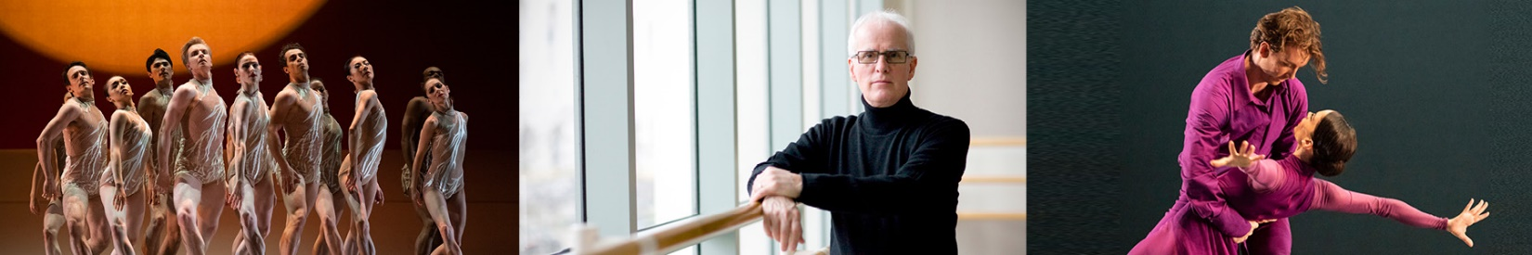(Left to right) San Francisco Ballet in Liang's *The Infinite Ocean* // © Erik Tomasson*;* Helgi Tomasson // © David Martinez; Dores André and Ulrik Birkkjaer in Benjamin Millepied's *Appassionata* // © Erik Tomasson

The season opens with **Christopher Wheeldon**’s ***Cinderella*** *(*[January 21–February 2](https://www.sfballet.org/season/2020-repertory/2020-Program-1)). A co-production with Dutch National Ballet, Wheeldon’s *Cinderella* features spectacular scenic and costume design by Julian Crouch, and is highlighted by the breathtaking tree and carriage sequence directed and designed by master puppeteer Basil Twist. It features lighting design by Natasha Katz and projection design by Daniel Brodie. The production was last performed at SF Ballet in 2017 and is set to the music of Sergei Prokofiev. *Cinderella* is one of ten commissions Wheeldon has created for SF Ballet, and his first full-length production for the Company.

Program 02 ([February 11–22](http://sfballet.org/season/2020-repertory/2020-Program-2)) features **Mark Morris**’ ***Sandpaper Ballet***, whichpremiered at San Francisco Ballet in 1999, and was last performed by SF Ballet in 2010. With costumes designed by fashion powerhouse Isaac Mizrahi and music by Leroy Anderson, it was described as a “light and slight, delightfully loopy sprawl of a pop dance…” (*San Francisco Chronicle)* at its premiere. **Liam Scarlett**’s ***Hummingbird***, premiered by SF Ballet in 2014, is an exhilarating and poignant set of three pas de deux set to Phillip Glass’ Tirol Concerto for Piano and Orchestra. Rounding out the program is **Stanton Welch**’s ***Bespoke****,* returning after its premiere at SF Ballet’s 2018 Unbound: A Festival of New Works.Expertly set to two violin concertos by J.S. Bach, *Bespoke* is a neoclassical work which explores dancers’ lifelong love of their art form through classical technique, and the artistry and beauty of live performances.

**A new SF Ballet commission by Trey McIntyre** will premiere on Program 03 ([February 13–23](http://sfballet.org/season/2020-repertory/2020-Program-3)) of the 2020 Season. McIntyre’s most recent work for SF Ballet, *Your Flesh Shall Be a Great Poem*, premiered at 2018’s Unbound: A Festival of New Works. **Edwaard Liang**’s ***The Infinite Ocean*** explores the transition from life to death, inspired by the passing of the choreographer’s father as well as friends in recent years. The work premiered during the 2018 Unbound Festival and is set to a commissioned score by Oliver Davis. The final ballet on Program 03 is **Harald Lander**’s one-act ballet for 40 dancers, ***Etudes***. The work begins with the corps de ballet at the barre in the daily ritual of ballet class, and through the course of the piece culminates to a bravura display of technical virtuosity. A tribute to classical ballet training, *Etudes* is performed to a set of Carl Czerny’s piano exercises orchestrated for ballet by Knudåge Riisager.

**George Balanchine**’s ***A Midsummer Night’s Dream*** returns to SF Ballet for the first time in 34 years [March 6–15](http://sfballet.org/season/2020-repertory/2020-Program-4). Based on the play by William Shakespeare, the two-act ballet is set to Felix Mendelssohn’s whimsical score of the same name. This radiant revival features set and costume designs by the late Martin Pakledinaz, a Tony Award-winning artist and long-time SF Ballet collaborator.

Program 05 ([March 24–April 4](http://sfballet.org/season/2020-repertory/2020-Program-5)) features **a new SF Ballet commission by** **Cathy Marston**. A master storyteller, Marston’s first commission for SF Ballet was *Snowblind,* based on Edith Wharton’s novel *Ethan Frome*, during the Unbound festival in 2018. **David Dawson**’s ***Anima Animus***, the choreographer’s first commission for SF Ballet, also returns from Unbound. Set to the music of Ezio Bosso, *Anima Animus* is, as Dawson puts it, “physically emotional virtuosity combined to make something human,” playing on Jungian concepts to reveal the rich contrasts of the female elements of the male psyche and vice versa. Also on Program 05 is Artistic Director **Helgi Tomasson**’s ***7 for Eight***. Created for eight dancers and set to four keyboard concerti by J.S. Bach, it was hailed as having “overflowed with spare and resonant poetry” (*San Francisco Chronicle, 2/28/04)* at its premiere.

**Alexei Ratmansky**’s ***The Seasons***, set to the score of the same name by Glazunov and co-commissioned with American Ballet Theatre (ABT), will receive its West Coast premiere on Program 06 ([March 26–April 5](http://sfballet.org/season/2020-repertory/2020-Program-6)). The world premiere performance at ABT will take place in May 2019. **Benjamin Millepied**’s ***Appassionata***makes an encore performance after its SF Ballet premiere in the 2019 Season. Created for six dancers to Beethoven’s *Appassionata* piano sonata, the ballet explores intricate and complex human relationships between three couples, beautifully balanced between serenity and ecstasy, intimacy and playfulness. Yuri Possokhov’s *Classical Symphony*, set to Prokofiev’s score of the same name, opens the program. The work premiered with SF Ballet in 2010, and in 2011 was called an “exhilarating and bold display of full-throttle academic pure dance” with the “sheer exuberance of its often unorthodox ballet virtuosity” (*The New York Times*) noted among its most striking elements.

***Jewels*** *by* **George Balanchine** returns [April 15–21](http://sfballet.org/season/2020-repertory/2020-Program-7). Inspired by jewelry designer Claude Arpels, Balanchine created the three-act, plotless ballet and named each act after a particular gem. With costumes for all three acts designed by Barbara Karinska, *Emeralds* is “an evocation of France—the France of elegance, comfort, dress, perfume” (The George Balanchine Trust), and is set to extracts from *Pelléas et Mélisande* and *Shylock* by French composer Gabriel Fauré. *Rubies* references the jazzy and modern America and is set to Stravinsky’s *Capriccio for Piano and Orchestra*. *Diamonds* is a nod to the grandeur of Imperial Russia and the Mariinsky Theatre and is set to Tchaikovsky’s *Symphony No. 3 in D major, Op. 29*.

The 2020 Repertory Season concludes with another Shakespearian story ballet, **Helgi Tomasson**’s classic ***Romeo & Juliet*** *(*[May 1–10](http://sfballet.org/season/2020-repertory/2020-Program-8)). Set to Sergei Prokofiev’s masterpiece of the same title and one of 20th century’s most beautiful scores, the production boasts opulent set and costume designs by Jens-Jacob Worsaae. This production of *Romeo & Juliet* is one of four productions recorded and released by Lincoln Center at the Movies: Great American Dance.   
  
**SF BALLET ON TOUR**

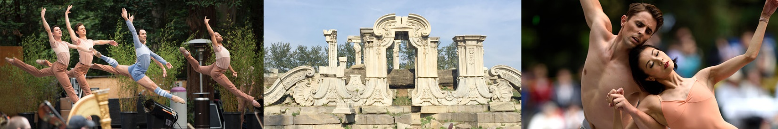(Left to right) San Francisco Ballet in Peck's *Rodeo: Four Dance Episodes* // © Erik Tomasson; 2015 China Tour // © San Francisco Ballet; Yuan Yuan Tan and Luke Ingham in Christopher Wheeldon's *After the Rain* // © Erik Tomasson

**San Francisco Ballet will present four programs featuring all European premieres at** [**London’s Sadler’s Wells**](https://www.sadlerswells.com/whats-on/2019/san-francisco-ballet/) **Theatre May 20–June 8, 2019**. Performances will include nine ballets commissioned by San Francisco Ballet, and one SF Ballet co-commission. Alexei Ratmansky’s *Shostakovich Trilogy* opens the tour, followed by three mixed repertory programs featuring mostly works from SF Ballet’s critically successful Unbound: A Festival of New Works, which was staged in San Francisco in April and May of 2018. Works include those by David Dawson, Edwaard Liang, Cathy Marston, Trey McIntyre, Justin Peck, Arthur Pita, Liam Scarlett, Stanton Welch, and Christopher Wheeldon. The SF Ballet’s last appearance at Sadler’s Wells was in 2012. For more information [visit the press release on the web](https://www.sfballet.org/about/media-center/press-releases/London_2019).

**SF Ballet will bring two distinct programs to** [**Ballet Sun Valley**](https://balletsunvalley.com) **on July 5 & 7, 2019 at the Sun Valley Pavilion.** SF Ballet was the first ballet company presented by Ballet Sun Valley upon its inception in 2012, and in 2019 will present programs that span the spectrum of ballet, including three highly acclaimed ballets from 2018 Unbound: A Festival of New Works. Theweekend also includes an education program, with SF Ballet dancers and SF Ballet School Faculty, teaching all levels of ballet to young students from around the country.

**SF Ballet is presented by The Royal Danish Ballet at the Royal Danish Opera House in Copenhagen, October 30–November 2, 2019, with four performances of Helgi Tomasson**’s ***Romeo & Juliet***. The work, which premiered at the San Francisco War Memorial Opera House in 1994, is set to Sergei Prokofiev’s iconic 1935 score of the same title. The 2019 tour marks a welcome return to Copenhagen for SF Ballet, which was last presented in the city in 2010 at Tivoli Concert Hall.

***NUTCRACKER* 75TH ANNIVERSARY**

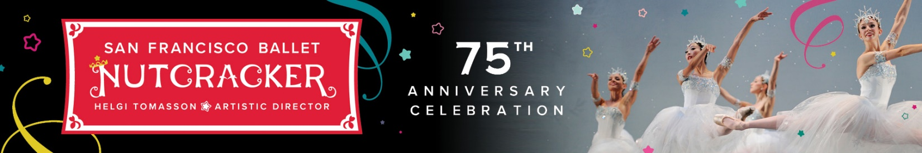  
San Francisco Ballet in Tomasson's *Nutcracker* // © Erik Tomasson

On Christmas Eve of 1944, **SF Ballet performed the first full-length production of *Nutcracker* ever staged in the United States, launching a national holiday phenomenon.** **The Company celebrates the 75th anniversary of that performance in 2019, with performances on December 11–29.** The 1944 production was choreographed by former Artistic Director Willam Christensen with costumes designed by Russell Hartley and sets by Antonio Sotomayor and was performed at the San Francisco War Memorial Opera House with a $1,000 budget. Today, *Nutcracker* is performed nationwide during the holiday season in cities large and small. SF Ballet’s current production of *Nutcracker* is choreographed by Helgi Tomasson and premiered in 2004. The production is set in 1915 in San Francisco during the Panama-Pacific International Exposition. It features scenic designs by Michael Yeargan, costume designs by Martin Pakledinaz, lighting designs by James F. Ingalls, projection designs by Wendall K. Harrington, and is performed to the music of Peter Ilyich Tchaikovsky. Celebrations in the 75th anniversary season will include enhanced pre-performance lobby experiences and other yet-to-be-announced activities throughout the city.

**Subscription and Single Tickets**

Principal series subscribers in the 2019 season can renewal their subscription packages now. Three, five, and eight program subscription packages to SF Ballet’s 2020 Repertory Season range in price from $77-$5,100 and go on sale to the public on August 6, 2019. Individual tickets for SF Ballet’s 2020Repertory Season, starting at $29, will be available at a later date in fall 2019. Ticket Services can be reached for more information at 415-865-2000 or visit [sfballet.org](http://www.sfballet.org/). Phone hours are Monday through Friday, 10 am to 4 pm.

**SAN FRANCISCO BALLET SCHOOL, EDUCATION, AND COMMUNITY PROGRAMS**

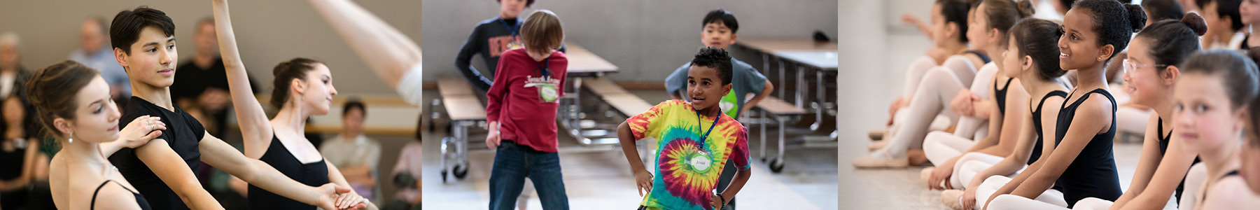  
(Left to right) Scenes from the 2018 San Francisco Ballet School open house // © Alexander Reneff-Olson; SF Ballet Dance in Schools and Communities Residency Program // © Chris Hardy; San Francisco Ballet School 2018 community scholarship program class presentation // © Erik Tomasson

SF Ballet’s robust training, education, and community programs reach more than 35,000 people in the Bay Area annually. The Company’s commitment to advancing diversity, equity, and inclusion within the dance field is reflected through its substantial efforts to recruit and train young dancers and choreographers of diverse backgrounds, to provide free and equitable access to arts education through its 40-year partnership with the San Francisco Unified School District, and to promote an inclusive art form by serving myriad sectors of the community that are often underserved.

SF Ballet School, led by renowned dancer and dance pedagogue Patrick Armand, was founded alongside the Company in 1933. Nearly 65% of San Francisco Ballet dancers trained at SF Ballet School, which today is considered to be one of the finest ballet academies in the world. Students in the School **appear in SF Ballet productions throughout the season**, including the annual *Nutcracker, Don Quixote* and *The Sleeping Beauty* in 2019. The School also presents the annual **Spring Festival** (formerly called Student Showcase), a series of three evenings of public performances in San Francisco showcasing SF Ballet School students performing works from some of the industry’s most innovative choreographers, as well as new choreography from students in the **Choreographic Fellowship Program**. The Choreographic Fellowship Program, created to give voice to student dancers of all backgrounds as dancemakers, supports one or more students each year through the cycle of creating a new work. The Fellows workshop their new ballets with School Faculty and their peers throughout the season and receive additional support from the Company, including a scholarship to the School; assistance with clearing music licensing; access to SF Ballet operations and production staff to gain insights into contracts and union agreements, music and production elements, creatives, and Company scheduling; a cash award; and a video of the performance for their portfolio. The School’s 11-month **Trainee Program** offers pre-professional training, and full tuition and housing to students selected from the School’s highest levels and other advanced students around the world. SF Ballet School Trainees will appear at Assemblée Internationale in Toronto in May 2020, performing a special commission by SF Ballet dancer and choreographer Myles Thatcher. With opportunities to perform throughout the U.S. and overseas, Trainees have been invited to perform in Tokyo, Cannes, Paris, Toronto, and Hamburg. One hundred percent of dancers who have completed the program have been hired by professional ballet companies, and many have joined SF Ballet.

SF Ballet School awards **more than $1.5 million in financial aid and merit-based scholarships to students each year** and is committed to assuring access, support, and opportunity to a diverse student body. Its Community Scholarship Program, which provides scholarships to students participating in SF Ballet’s Dance in Schools and Communities (DISC) program, awards more than **$420,000 annually to students in the San Francisco Unified School District (SFUSD)** to receive dance training at the SF Ballet School.

**The 2019–20 season marks the 40th anniversary of SF Ballet’s flagship DISC Residency Program.** A partnership with SFUSD, DISC is an in-school dance program offered free of charge to more than 35 SFUSD schools, serving more than 2,500 school children in more than 100 elementary and middle school classrooms. Highlights of the program are the nine-week dance residencies and professional development workshops for K-12 educators. Those participating in the DISC residencies also attend the annual SF Ballet Student Matinee performances free of charge, which brings nearly 6,000 school children to the War Memorial Opera House each season to see the Company perform. In addition, at the end of the residency, SF Ballet invites 60–100 students to attend SF Ballet School on a one-year full scholarship through the Community Scholarship Program. DISC’s after-school residency program currently serves five schools in the Bayview, Mission, Visitacion Valley, and Tenderloin districts of San Francisco.

**On the 40th anniversary of DISC**, SF Ballet redoubles its commitment to bring equitable access to arts education. In the 2019–20 season, DISC will expand the number of in-school and after-school dance residencies for elementary and middle schools and, for the first time, will also serve high schools. A new partnership with Oakland School for the Arts will bring their dance students to SF Ballet performances at the War Memorial Opera House, career planning seminars to their campus, and offer opportunities to engage their dance students through master classes and special workshops.

San Francisco Ballet’s footprint in the community extends beyond the K–12 student population. The 24-week **Parkinson’s Disease Dance Class** series in partnership with Kaiser Permanente takes place at SF Ballet studios throughout the year, and **Sensory-Friendly Family Workshops and Relaxed Dress Rehearsals** brought the special needs community from Autism un Bay Area, Pomeroy Recreation and Rehabilitation Center, College of Adaptive Arts, and Oak Hill School to the Opera House in the 2019 Season. SF Ballet’s **partnership with the Boys & Girls Clubs of San Francisco** provides free ballet and dance classes for youth ages 6–18, including Summer Dance Camp, dance residencies at clubhouses across the City, and various field trips and dance days throughout the season. SF Ballet’s **annual appearance at the Stern Grove Festival and SF Ballet School’s appearance at Fan Fest are free and open to the public.**

**ABOUT SAN FRANCISCO BALLET**

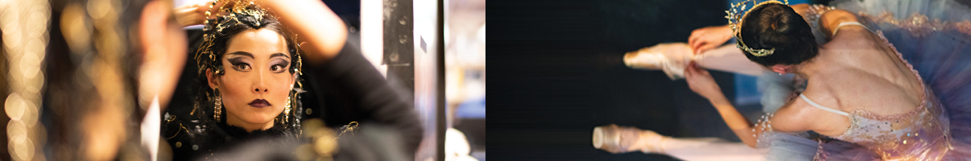(Left to right) WanTing Zhao getting ready to dance in Tomasson's *The Sleeping Beauty*; San Francisco Ballet backstage during a performance of Tomasson's *The Sleeping Beauty* // All © Erik Tomasson

San Francisco Ballet, long recognized for pushing boundaries in dance, has enjoyed a long and rich tradition of artistic “firsts” since its founding in 1933, including performing the first American productions of *Swan Lake* and *Nutcracker*, as well as the first 20th-century American *Coppélia*. SF Ballet is one of the three largest ballet companies in the United States and currently presents more than 100 performances annually, both locally and internationally. The mission of SF Ballet is to share its joy of dance with the widest possible audience—in its community and worldwide—and to provide the highest caliber of dance training in its School. Under the direction of Helgi Tomasson, the Company has achieved an international reputation as one of the preeminent ballet companies in the world.

*Cinderella*© by Christopher Wheeldon

**For photos and other press inquiries, please contact SF Ballet publicity department:**Kate McKinney, PR & Communications Manager, [kmckinney@sfballet.org](mailto:kmckinney@sfballet.org) // 415.865.6610  
You You Xia, Director of Communications, [yxia@sfballet.org](mailto:yxia@sfballet.org) // 415.865.6603

**Connect with us via “sfballet” on:**

[](https://www.facebook.com/sfballet) [](https://www.instagram.com/sfballet/) [](https://twitter.com/sfballet) [](https://www.youtube.com/SFBallet)

**Visit our blog at** [**www.sfballet.org/explore**](http://www.sfballet.org/explore)