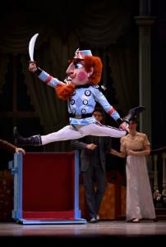 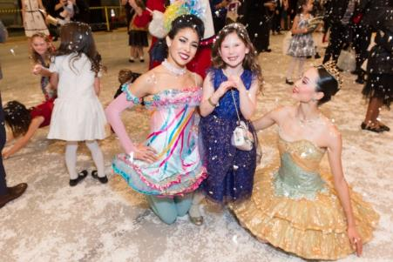 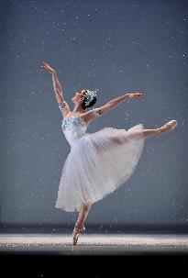
From L to R: SF Ballet in Tomasson’s Nutcracker (© Erik Tomasson) // Nutcracker Benefit Luncheon 2018 (© Susana Bates for Drew Altizer Photography) // Julia Rowe in Tomasson’s Nutcracker (© Erik Tomasson)
SAN FRANCISCO BALLET PRESENTS THE 75th ANNIVERSARY OF AMERICA’S FIRST NUTCRACKER, DECEMBER 11–29
Community events, giveaways, and more commemorate the Bay Area’s Nutcracker legacy
Tickets to Nutcracker on sale now
SAN FRANCISCO, SEPTEMBER 26, 2019—San Francisco Ballet (SF Ballet) presents the 75th anniversary of America’s first full-length Nutcracker with a myriad of events and giveaways this holiday season, culminating in performances of Artistic Director and Principal Choreographer Helgi Tomasson’s set-in-San Francisco Nutcracker, danced to Tchaikovsky’s timeless score, December 11 ̶ 29, 2019 at the War Memorial Opera House.
On Christmas Eve, 1944, SF Ballet presented America’s first full-length Nutcracker at the War Memorial Opera House, before making stops in Oakland, Sacramento, and Stockton—giving California the country’s first taste of “Nutcracker fever.” In the 75th anniversary season, SF Ballet celebrates the Bay Area’s Nutcracker legacy beginning October 10, when the “75 Days of Nutcracker” countdown kicks off across SF Ballet’s online platforms. Throughout the countdown, SF Ballet will give away 75 pairs of Nutcracker tickets and signed pointe shoes, share exclusive 75th anniversary Nutcracker stories, and invite users to reconnect online over their own Nutcracker memories. On November 3, Exploring Nutcracker brings together Joan Coffey-Caton Vickers and Janet Sassoon Upton, members of the original 1944 production; a panel of Claras from past SF Ballet Nutcrackers; and UC Irvine’s Jennifer Fisher, PhD, Nutcracker scholar and author of Nutcracker Nation, to discuss the ballet’s influence on San Francisco and beyond. On December 10, Nutcracker characters will appear at Holiday Heroes at Oracle Park, and on December 11, Claras and other student performers from the past 75 years of SF Ballet’s Nutcracker will attend the opening night performance, filling the Opera House with historic numbers of SF Ballet School alumni who have taken on the roles of Clara, soldiers, party children, and more. On December 18, Nutcracker After Hours invites members of The List and other young professionals to a post-performance party, and Passport Performances return throughout the season, offering plush toys, costumed characters, carolers, and special treats to patrons at no additional cost. SF Ballet continues its partnership with the Boys & Girls Club of San Francisco, inviting their members to the Nutcracker Benefit Luncheon on December 15, and continues its support of the Children’s Enchantment Fund, which has helped more than 30,500 Bay Area children and their families attend SF Ballet’s Nutcracker at no cost.
NUTCRACKER PERFORMANCE CALENDAR & TICKETS
EVENT CALENDAR
HISTORY NARRATIVE, TIMELINE, & VIDEO
CURRENT & HISTORIC PHOTOS (New user? Click “Register”)
ABOUT HELGI TOMASSON'S NUTCRACKER
PRODUCTION CREDITS
About Exploring Nutcracker: SF Ballet hosts Exploring Nutcracker on Sunday, November 3 from 1 ̶ 4:30pm at 455 Franklin Street, bringing together artists and scholars from the past and present of Nutcracker in America. Exploring Nutcracker’s guests include Joan Coffey-Caton Vickers and Janet Sassoon Upton, original members of the 1944 production; UC Irvine’s Jennifer Fisher, PhD, Nutcracker scholar and author of Nutcracker Nation; and a panel of dancers who performed as Clara in SF Ballet’s productions throughout the past 75 years, including Margaret Bates, MD (Clara in ’62 and ’63), SF Ballet’s Board of Trustees member Catherine Slavonia, PhD (’78), CalArts faculty member Ariel Osterweis, PhD (’85), Articulating Body’s Marimba Gold Watts (’92), and Caroline Hearst (’04), who performed the role of Clara in 2004, when Helgi Tomasson’s Nutcracker premiered. Press are encouraged to attend Exploring Nutcracker; details regarding a light reception and post-panel interviews will be announced soon.
About Nutcracker Benefit Luncheon: The Nutcracker Benefit Luncheon returns on Sunday, December 15 at the Zellerbach Rehearsal Hall, with proceeds from the event benefitting SF Ballet’s School and Youth Programs and the SF Ballet School scholarship fund. Members of the Boys & Girls Club of San Francisco (BGCSF) and the Bay Area are invited—free of charge—to join this year’s luncheon, which includes crafts, photo moments with Nutcracker characters, and a Build-a-Bear station, all preceding a matinee performance of Nutcracker at the War Memorial Opera House. “This type of engagement is powerful for Boys & Girls Club youth who are often disconnected from the schools, institutions, and communities where they live,” says Joni Lachman, BGCSF Vice President, Institutional Gifts. “Youth participating in this partnership are now ambassadors for arts in San Francisco and, as they grow up, will find a place for themselves in the larger SF arts world.” Learn more about SF Ballet’s BGCSF partners’ experience at the Nutcracker Benefit Luncheon at this link.
Free commemorative program books for all: This year, SF Ballet makes its 75th anniversary commemorative book free of charge to all guests. Guests will also experience festive décor around the Opera House, including romantic snowfalls and twinkling lights.
Please contact Kate McKinney at kmckinney@sfballet.org for all press inquiries. Casting for Nutcracker will be available at this link one week before each performance.
About Nutcracker’s U.S. debut at SF Ballet:
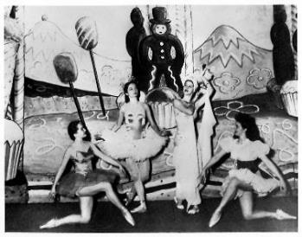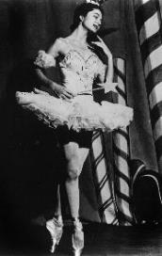 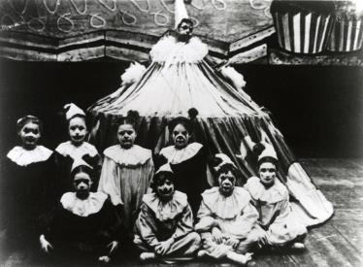
From L to R: Jocelyn Vollmar and members of SF Ballet in Willam Christensen's Nutcracker, 1944; Jocelyn Vollmar as the Sugar Plum Fairy, 1949; SF Ballet in Christensen's Nutcracker, 1944. // © San Francisco Ballet. Photos courtesy SFMP+D.
America’s first full-length Nutcracker, choreographed by Willam Christensen, was held at the War Memorial Opera House on Christmas Eve, 1944, before touring to Oakland, Sacramento, and Stockton. Christensen prepared for the ballet by consulting George Balanchine and Alexandra Danilova, who were visiting San Francisco with the Ballet Russes de Monte Carlo in November of 1944. Balanchine and Danilova had both danced in productions of The Nutcracker in Russia, and while they advised Christensen on elements of the original production, they ultimately encouraged him to create his own choreography.
Wartime restrictions limited Christensen’s budget, leaving dancers like Jocelyn Vollmar and Gisella Caccialanza Christensen—America’s first Snow Queen and Sugar Plum Fairy, respectively—to source their own fabric and make their own tutus for the premiere. The production included costume designs by Russell Hartley (he also danced the Dance of the Buffoons in the premiere) and set designs by South American painter and caricaturist Antonio Sotomayor. Following Nutcracker’s debut in the capital city, The Sacramento Union wrote, prophetically: “We can’t understand why a vehicle of such fantastic beauty and originality could be produced in Europe in 1892 with signal success and never be reproduced in its entirety in this country until 1944. Perhaps choreographers will make up for lost time from now on.” By the late 1960s, Nutcracker had become an annual American tradition.
Willam Christensen’s 1944 production marked the first of five total Nutcracker productions in SF Ballet’s history; view the timeline for more information.

About Artistic Director and Principal Choreographer
Helgi Tomasson’s Nutcracker:
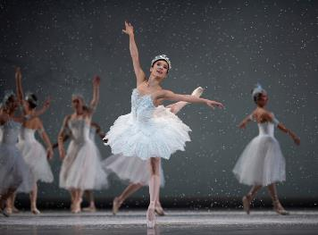 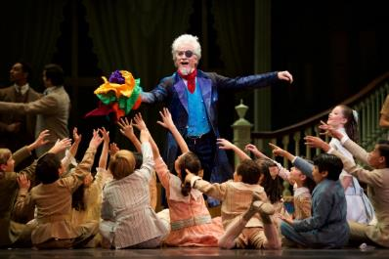
From L to R: Frances Chung in Tomasson’s Nutcracker // Val Caniparoli in Tomasson’s Nutcracker (© Erik Tomasson)
Running December 11 ̶ 29, 2019 at the War Memorial Opera House, Artistic Director and Principal Choreographer Helgi Tomasson’s Nutcracker speaks “to and for San Francisco” (Dance Magazine). Set in San Francisco in 1915 during the world’s fair, the Panama-Pacific International Exhibition, Nutcracker features designs by Tony Award–winners Michael Yeargan (scenic) and Martin Pakledinaz (costume), lighting design by James F. Ingalls, and projection design by Wendall K. Harrington. “Mr. Tomasson has fused the Exposition’s ideas of hope and progress with the equally universal childhood hopes for happiness of Clara … Happiness is the San Francisco Ballet’s new Nutcracker,” reported The New York Times in 2004, the year of the ballet’s premiere.
The production elements of Tomasson’s Nutcracker are set on a grand scale:
- With few exceptions, every dancer on SF Ballet’s roster will dance in Nutcracker during the 2019 run of 31 performances.
- More than 160 students from San Francisco Ballet School will perform in student roles.
- 600 pounds of “snow” are used for each performance, requiring at least 6 stagehands to deploy.
- The Christmas tree grows to over 30 feet tall.
- Martin Pakledinaz’ costumes consist of over 300 pieces, including the Snow Queen’s tutu, which features 300–500 Swarovski crystals and took around 80 hours to construct by hand.
- Drosselmeyer’s coat clocks in as the most expensive costume at $11,000.
- The Act I ballerina doll’s tutu weighs 18 pounds.

Nutcracker Performance Calendar & Tickets
Tickets for Nutcracker performances start at $25 and are on sale now. Tickets may be purchased by calling Ticket Services at 415-865-2000, open Monday through Friday, 10am to 4pm, or by visiting sfballet.org/nutcracker. Groups of 20 or more can save 20% on select performances; call Group Sales Representative Nannette Mickle at 415-865-6785 for more information.
Nutcracker Performance Calendar
DAY | DATE | TIME
Wednesday  Thursday  Friday  Saturday  Sunday  Tuesday  Wednesday  Thursday  Friday  Saturday  Sunday  Monday  Tuesday  Thursday  Friday  Saturday  Sunday | December 11  December 12  December 13  December 14  December 15  December 17  December 18  December 19  December 20  December 21  December 22  December 23  December 24  December 26  December 27  December 28  December 29 | 7 pmᶺ  11 am, 7 pmᶺ  2 pm, 7 pmᶺ  2 pm⁺, 7 pm⁺  2 pm, 7 pmᶺ  7 pm  11 am, 7 amᶺ  2 pm, 7 pmᶺ  2 pm, 7 pm⁺  2 pm⁺, 7 pm⁺  2 pm⁺, 7 pm⁺  2 pm⁺, 7 pm⁺  11 am⁺, 4 pm⁺  2 pm, 7 pm  2 pm, 7 pm  2 pm, 7 pm  2 pm

ᶺ Denotes Passport Performance
⁺ Denotes VIP Box Experience Performance

Nutcracker 75th Anniversary Event Calendar
Date & Time | Event | Details
Thursday, October 10, 2019 | “75 Days of Nutcracker” begins | SF Ballet’s online platforms host daily giveaways, stories, and more, counting down the days until the 75th anniversary of America’s first Nutcracker on December 24, 2019.  www.sfballet.org and @SFBallet on Instagram, Twitter, and Facebook
Sunday, November 3, 2019  1 ̶ 4:30 pm  SF Ballet Studios  455 Franklin Street | Exploring Nutcracker;  Press Q&A | Exploring Nutcracker presents Joan Coffey-Caton Vickers and Janet Sassoon Upton, members of the original 1944 production; a panel of Claras from past SF Ballet productions; and UC Irvine’s Jennifer Fisher, PhD, Nutcracker scholar and author of Nutcracker Nation.
Wednesday, December 11, 2019  7 pm  War Memorial Opera House  301 Van Ness Ave | Opening Night of Tomasson’s Nutcracker | Historic numbers of Claras and other SF Ballet School Nutcracker alumni from the past 75 years will fill the War Memorial Opera house alongside the public.
Wednesday, December 18, 2019  Post-performance  Zellerbach Rehearsal Hall  300 Franklin Street | Nutcracker After Hours | Members of SF Ballet’s The List and other young professionals are invited to Nutcracker After Hours, a post-performance party with a DJ, dance floor, and Nutcracker-themed drinks and appetizers.
Sunday, December 15, 2019  11:30 am  Zellerbach Rehearsal Hall  300 Franklin Street | Nutcracker Benefit Luncheon: Land of Dreams | Sweet treats, crafts, and photos with costumed characters delight at this annual luncheon. Proceeds from the event benefit SF Ballet’s School and Youth Programs and the SF Ballet School Scholarship fund.
Tuesday, December 24, 2019  11 am & 4 pm  War Memorial Opera House  301 Van Ness Ave | 75th anniversary of Nutcracker’s American debut | On Christmas Eve, 1944, SF Ballet presented America’s first full-length production of Nutcracker. The 2019 Christmas Eve performances mark the 75th anniversary – to the date – of the historic occasion.

Nutcracker Production Credits
Composer: Peter Ilyich Tchaikovsky
Choreographer: Helgi Tomasson
Scenic Design: Michael Yeargan
Costume Design: Martin Pakledinaz
Lighting Design: James F. Ingalls
Projection Design: Wendall K. Harrington
World Premiere (full-length production): December 17, 1892—Shchelkunchik (original Russian title), Imperial Ballet, Mariinsky Theatre; St. Petersburg, Russia. Choreography for this production by Lev Ivanov, libretto by Marius Petipa.
United States Premiere (full-length production): December 24, 1944—San Francisco Ballet, War Memorial Opera House; San Francisco, California. Choreography for this production by Willam Christensen.
Premiere (New Production): December 17, 2004—San Francisco Ballet, War Memorial Opera House; San Francisco, California.
The 2004 premiere of Helgi Tomasson’s Nutcracker was made possible by Lead Sponsors The Herbert Family and The Swanson Foundation, and Sponsors Yurie and Carl Pascarella, Kathleen Scutchfield, and The Smelick Family.
Casting will be available at https://www.sfballet.org/season/casting.
* * * *

